* The lid must be on the chamber to perform photomanipulation
* The 405 laser is steered into the detection objective on the right side. There is a blocking filter that prevents the light from reflecting back from the chamber down the detection path towards the camera. On the left side, we do not have that blocking filter. Because the left doesn’t have the blocking filter, we will want to turn off that camera for calibration. Since the 405nm laser is coming from the right side, we want to calibrate to the right camera, and find the features to photo manipulate on the right view.
* NOTE: Long Camera = left, short camera right? Need to confirm with Dane if we really care about blocking one off? Although the short camera is the only one with the DAPI filer

1. Go to calibration tab
2. Under Photomanipulation
   1. Press “Enable Photomanipulation” switch
   2. Press “Laser shutter” switch
   3. Press “Lighthub 405nm” switch (can also be done with all other wave lengths)
   4. Set laser power to 100%
   5. Select right camera from the list of “Cameras to use”

1. Under the Detection box
   1. Set the filter to BP 418-462
   2. Change Dichroic ablation filter to “405/488/561/642 notch)
2. Under cameras
   1. Unlink the cameras and set the right to area, left to off
   2. Set exposure to 100ms (we were successful at 50ms)

1. Return to In the Photomanipulation box: Press “start” in the photomanipulation Calibration

1. Confirm that there is a small spot visible on the right camera. The histogram should not be saturated. If so, reduce exposure time to be nice to the camera.

1. Press the “Next 1 of 5” button in the Photmanipulation Calibration tab

1. Verify the next four points have the purple circle centered on the 405nm spot. Press retry and increase exposure if this fails.
2. The 405nm laser is now calibrated. The dotted outline shows you the bounds where you may draw photomanipulation objects.
3. IF IT FAILS:
   1. First, check your filters and that the notch filter is in. You should be able to see a spot outside of any of the Wells.
   2. The focus of the spot of the CALM trulive system is around 60-75 for the laser focus.
   3. If you are having trouble seeing the spot:
      1. Make sure the settings are correct for the filter, open the laser shutter and give the laser power the then click live on the camera. Here you can adjust the laser focus and the exposure time while looking at the laser spot live.
4. To demonstrate this is working, we can use the left camera.
5. Change the left camera to area mode
6. Change your filters to BP 457-501

1. On the right side of the screen, you can choose whether to draw a line, rectangle, circle, or single point as a photomanipulation object. NOTE!!! Do not draw PM objects while the cameras are live. This can be buggy.
2. I will select a square. Click onto the right camera to define the upper left corner of your region of interest. Drag the bounds to create a shape.

1. Go to the dashboard to change the photomanipulation object settings
2. Increase laser power to 100%
3. The software must rasterize the vector object you created on the camera chip. To do this, it will create a coordinate system where it goes from the top left to the bottom right, drawing a point with spacing defined by the “spacing” parameter. For each one of these points, the laser will be turned on and parked in that spot for the amount of time defined in the “Dwell time” parameter. You can repeat this scan with the “Repetitions” parameter. The interaction of all these terms will give you a total “Duration”. Be sure this does not exceed several seconds. Typically if we are trying to do a precise manipulation, we will have small regions to fill that may take on the order of tens to hundreds of milliseconds.

1. Press start live
2. Press “Fire” in the Photomanipulation Module window
3. On the left cam you will see the individual spots. I set the display to Range mode with a min of 100 and a max of 200. I flipped the left camera as well.

Experimental Design

1. We will create an experiment with three events.
   1. Event 1 will be a single Z stack of two channels. This is our pre-manipulation time point.
   2. Event 2 will be the photomanipulation. For this event, we will create a channel with the cameras off so we don’t write data or expose the cameras to the PM laser.
   3. Event 3 will be identical to Event 1, but will be timed after the PM event. This is our post-manipulation time point.
2. Create three channels. Two channels will be for GFP and DSred, set these up as usual.

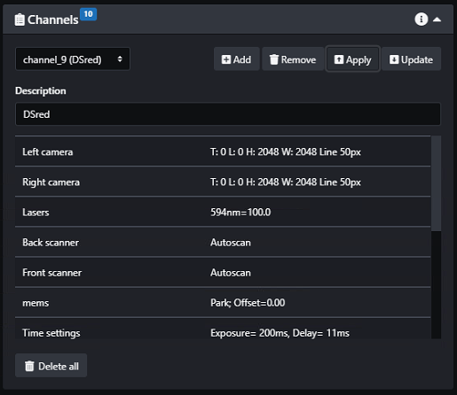

1. Create a third channel. This channel will not have any imaging lasers switched on, and will have both cameras set to “off”.

1. Create a stack through the sample.

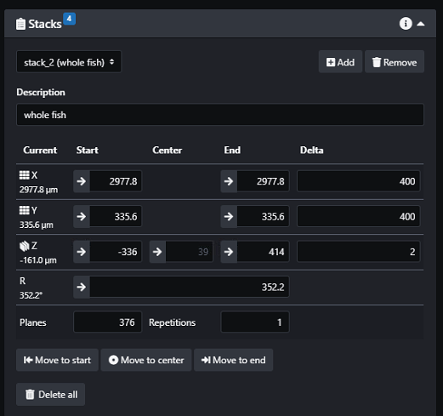

1. Create a second stack at the point of interest that you want to manipulate. Remember we want this to be a feature oriented towards the right objective.

1. Create the first Event. This is out pre-manipulation imaging going through the entire sample with the two imaging channels.

1. To estimate the time needed for this first event, change the repetitions to 2 and interval to 1s. This will throw a warning with the expected runtime of the experiment.

1. Change the Triggers for Event 1 back to 1 Repetition with no interval or start delay.
2. Create the second Event. This is the photomanipulation event. Select the single plane of interest that was saved as a separate stack. For the channel, select the PM channel with no cameras on. Then select the PM object in the drop-down menu.

1. Here we can simply press confirm.

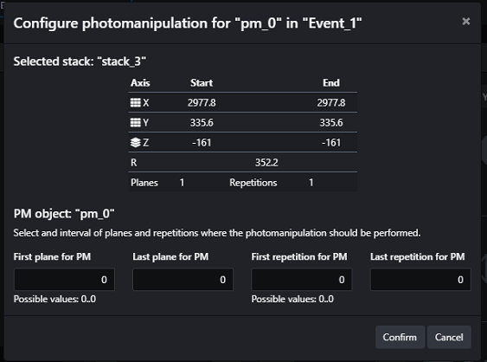

NOTE: An alternative approach is to use the same stack used for imaging. The PM object configuration will ask you to select the planes of interest in this case.

* The disadvantage of using the imaging stack is that the user must know what plane # in the series the PM object is supposed to occur at. However, if the user would like the perform a manipulation across multiple Z planes, the first, last, and spacing can be defined here.
* Here we are using the 375 plane imaging stack and performing PM at planes 50-60.
* For the purpose of this documentation, we will use the design in step 34-35.

1. For the second event, set the “start after” in the triggers window to the length of time the software determined the first event to take. Since it was estimated 2m 6s, I set 2m 10s.

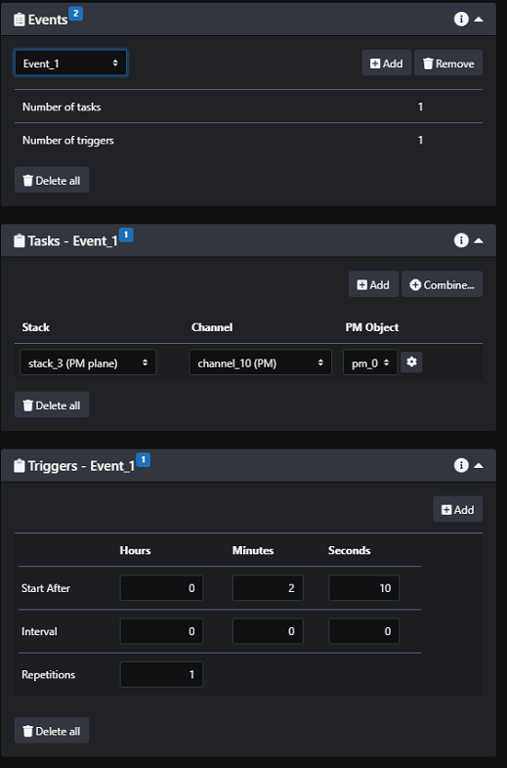

1. Create a third event. This is the post-manipulation imaging event. Create two tasks to image the full extent of the sample similar to the first Event.
2. Set the “Start after” to the sum of the second event start after, plus the PM object time. Since we set 2m 10s and the PM object time is 2.6s, I will set a start after of 2m 20s.

1. Run the experiment. You will not see any camera activity during the PM event.